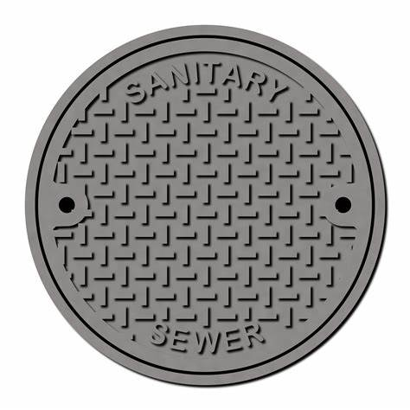

PLEDGE OF ALLEGIANCE
ROLL CALL OF DIRECTORS

APPROVAL OF MINUTES
- Minutes will be approved at the regularly scheduled meeting on May 20 2026

PUBLIC COMMENTS
- Nothing Scheduled

ENGINEERING
- New rules & regulations presentation – Bill Willis

NEW BUSINESS
- Nothing Scheduled

ADJOURNMENT

