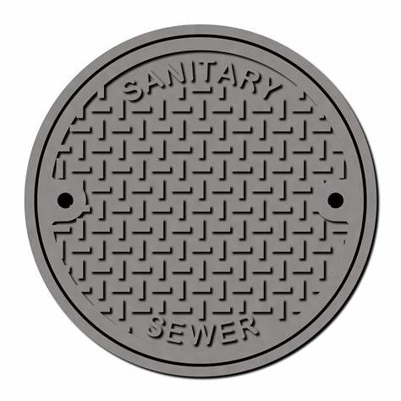

PLEDGE OF ALLEGIANCE
ROLL CALL OF DIRECTORS

APPROVAL OF MINUTES
- Minutes for the meeting held June 17, 2026

PUBLIC COMMENTS
- Nothing Scheduled

ACTION ITEM
- Nothing to report

OPERATIONS
- Fruitdale Sanitation District Data Sheet
- Inspectors Report

FINANCIAL
- Income & Expense Report (June, 2026)
- General Funds Report (Bonds, CD’s, Checking Acct, Savings Acct.)
- Payment of Bills (Presented at Meeting)
- Pre-approved Bills for (Aug, 2026)

BILLING
- Delinquent Report
- Past Due Report

UNIFICATION AGREEMENTS
- Nothing to report

LEGAL REPORT
- Attorney Report – Frank Suyat

ENGINEERING
- Engineers Report – Bill Willis

PERSONNEL
- Nothing to report

CONTINUED/OLD BUSINESS
- Nothing to report

NEW BUSINESS
- Motion to appoint controlling party

ADJOURNMENT

